Probability Assignment: Name: ____________________________
Your assignment is to create an experiment in which you will be determining the theoretical and experimental probability of an event.

- Think about what manipulative you will use (coins, spinners, dice, colored blocks, cards)
- Write your experimental problem
- Determine what your favorable outcome will be.
- Create a chart or tree diagram to determine all the possible outcomes.
- Determine your theoretical probability. Show your answer as a percent, fraction, and ratio.
- Perform your experiment 100 times. Create a chart to keep track of your data.
- Calculate the experimental probability.
- Compare your theoretical and experimental probability. Explain your reasoning.
- Present your information on a poster (11x17)
 | Fully meeting expectations, with enriched understanding (EU) | Fully meeting grade level expectations (FM) | Mostly meeting grade level expectations (MM) | Not yet meeting grade level expectations (NY)
SP7.3 Demonstrate an understanding of theoretical and experimental probabilities for two independent events where the combined sample space has 36 or fewer elements | You show a deep understanding of probability by designing and carrying out a detailed experiment containing two or more independent events to determine sample space, theoretical and experimental probability. You express probability in a variety of formats and you are able to explain, with insight, why your results may or may not be similar. | You show your understanding of probability by designing and carrying out an experiment containing two independent events to determine sample space, theoretical and experimental probability. You express probability in a variety of formats and can explain your reasoning. | With help, you show a basic understanding of probability by designing and carrying out an experiment containing two independent events. You are having some difficulty determining sample space, theoretical and experimental probability, or expressing probability in a variety of formats. Explore and practice each requirement enough that you can do it well on your own. | You are having difficulty creating an experiment to determine probability. What are independent events? How can a tree diagram show sample space? What is the difference between experimental and theoretical probability? How can we change fractions to percents and ratios?
Feedback:

Determine the probability of getting an even number and heads when tossing a tetrahedron die (1-4) and tossing a coin.
Theoretical:
 | 1 | 2 | 3 | 4
Heads | 1-H | 2-H | 3-H | 4-H
Tails | 1-T | 2-T | 3-T | 4-T
Theoretical probability: 2/8, 2:8, 25%
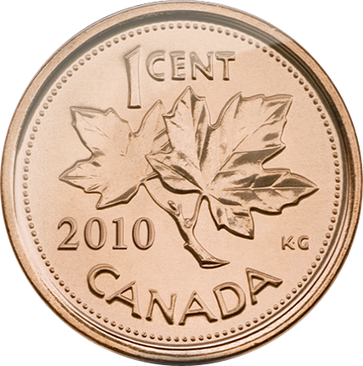
Experimental:
 | Number of Times | TOTALS
1-H |  | 12
2-H |  | 12
3-H |  | 12
4-H |  | 13
1-T |  | 11
2-T |  | 14
3-T |  | 11
4-T |  | 15
Experimental Probability= 25/100, 25:100, 25%
Conclusion: My value of experimental probability ……..

