Rubric for Listening ELA 5 Name __________________________________

 | 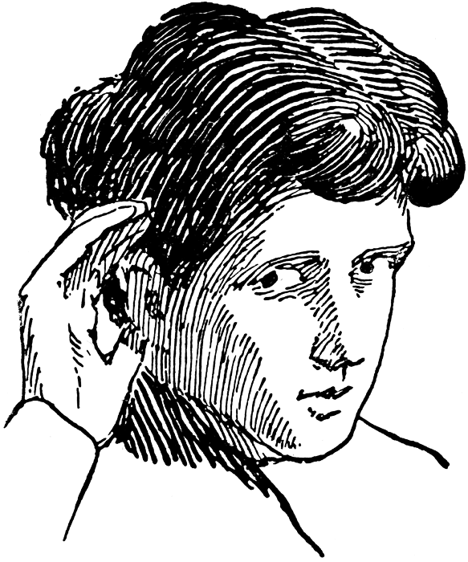 | Fully meeting expectations, with enriched understanding (EU) | Fully meeting grade level expectations (FM) | Mostly meeting grade level expectations (MM) | Not yet meeting grade level expectations (NY)
Ideas and Information | Identify and summarize main ideas  (paraphrase) | You demonstrate a significant recall and clear understanding of ideas, concepts, and/or information. | You demonstrate a good recall and clear understanding of ideas, concepts, and/or information. | You are able to recall parts of the ideas, concepts, and/or information. What listening strategies and behaviors would help you to gain further understanding? | You have difficulty recalling main ideas. What listening strategies and behaviors would help you to recall and understand the main idea of what you heard? What does attentive listening look like and sound like?
Ideas and Information | Identify supporting details | Wow! You were clearly engaged in this text! You can recall both major and minor supporting details and expand on how they impacted the overall message. | You are able to identify most of the supporting details. | You are able to identify some of the supporting details. Make notes to help you recall and identify important details. | Engage in active listening behaviors. Make notes to help you recall and identify important details.
Ideas and Information | Id Identify opinions | You can clearly identify the opinion being shared and can generate your own opinion about whether you agree with what is being said or not and may even be able to share how others may feel about the text. | You can identify the opinion being shared but are not yet making connections to your own opinion or the opinions of others. | With support you are able to identify opinions when key information and ideas are discussed with you.  What information do you need to listen to identify opinions? | You have difficulty figuring out the opinion being shared. What point is the speaker trying to make? What is it that he/she really cares about?
 | N jI Interpret verbal and non-verbal messages, purposes and perspectives | Your engagement in the listening activity allows you to pick up on all the important clues and anticipate what is coming next. | You are able to tune in to the important cues and anticipate what is coming next. | Stay engaged throughout the entire presentation, in order to tune in to the important cues that will help you anticipate what is coming next. | When you engage in active listening behaviors, you will be able to tune in to the important cues to anticipate what is coming next. Make sure you know what good listeners do.
 | D Differentiate between verifiable fact and opinion | By giving complete and thoughtful evidence and explanation, you are able to distinguish clearly between the fact and opinion and even elaborate on the connection to the message. | By giving some evidence and explanation, you are able to distinguish what fact is and what opinion is. | You are beginning to see that fact can be proven and opinion is a viewpoint. Look for evidence to support this distinction. | Fact can be proven, whereas opinion is a viewpoint. What evidence would support this distinction?
Text structuresand features | Identify text structures and features | You can insightfully explain how the key techniques are used to achieve a successful presentation. You have a deep understanding of the unique structure and features or speech and can decipher if the message was clear and strong. | You recognize the key techniques used in a successful presentation. You have a clear understanding of how speech uniquely delivers a message. | With assistance you recognize some of the techniques of a successful presentation. You are beginning to understand speech and how to listen well for the message. More time could be spent looking at the features of speech.  Do you understand the main message? If yes, what is your opinion of this message? | Even with assistance, you are struggling to understand how speech is organized and how to listen for a purpose. What are some of the techniques used in a successful presentation?  How does this impact the message? Ask yourself why you are listening. What makes it difficult for you to understand the message?
Respond to and analyze texts | Ask questions to seek more information | You are asking insightful questions that not only deepen understanding but provoke new questions. There is strong evidence of deeper level thinking. | You are asking meaningful and relevant questions to deepen your understanding. | You are starting to ask questions. What other questions can you ask to clarify your understanding and /or to make the information more clear? | What is it that you are trying to find out?  What questions can you ask that will better help you understand what you are listening to?
Respond to and analyze texts | Analyze and evaluate message and presentation | You are able to explain your viewpoint in depth in response to hearing the message in the presentation. You clearly understand what the components of an effective presentation are. | You are able to formulate your own position or point of view in response to the presentation. You have an understanding of most of the components of an effective presentation. | You seem unsure of the theme or message of what you have heard. You needed some help clearly recognizing these elements in order to formulate your own opinion and/or point of view. | Think about your own position or point of view in response to the presentation. What did you like? What didn’t you like? Explain why?  How does this information apply to your life? Can you relate to what was said?
Respond to and analyze texts | Draw conclusion about ideas and strategies | You have checked your understanding of the message and presentation through reflections, making connections, inferences and making and confirming predictions in order to establish whether or not you support what you have heard. | You are able to draw conclusions about presenter’s viewpoint and/or values and message and presentation. | You are starting to use some of the facts and details that you heard to come to a decision about whether you agree or not with what you have been listening to. | Make a decision after thinking about all that you have heard. Ask, “How can I use all the facts and details to make a decision about the information?”
Feedback:

