
TABLEAU TARGET Sheet
Student_____________________

SELF ASSESSMENT | TARGET | Teacher Reflections
EU FM MM NY  improved | I can describe the characteristics of a story that make it a good candidate for a tableau.  a)  b)  c)  d)
EU FM MM NY  Improved | I can convey emotion without movement through body language. List emotions from different tableaus provided:  a)  b)  c)  d)
EU FM MM NY  Improved | I can describe what a tableau is.  Description:
EU FM MM NY  Improved | I can identify the main idea of other group’s tableaus.  Message 1  Message 2  Message Group 3
EU FM MM NY  Improved | I can list the qualities that make a tableau more engaging.  a)  b)  c)  d)
EU FM MM NY  Improved | I am able to decide on the best camera angle to showcase the tableau. I can operate a camera and frame a photo.
EU FM MM NY  improved | My group was able to use appropriate visual aids (costume, props, etc to enhance the message.  List item (s):
EU FM MM NY  improved | I can describe why I was drawn to the scene that I chose. Explain.
EU FM MM NY  improved | I can take constructive feedback and use it to improve my work next time. From the feedback I received I will:  Goal 1  Goal 2

Tableau | Student reflections
Message/Meaning:

Main emotion:

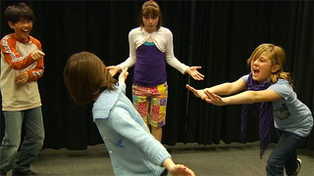 | Message/Meaning:  Main emotion:
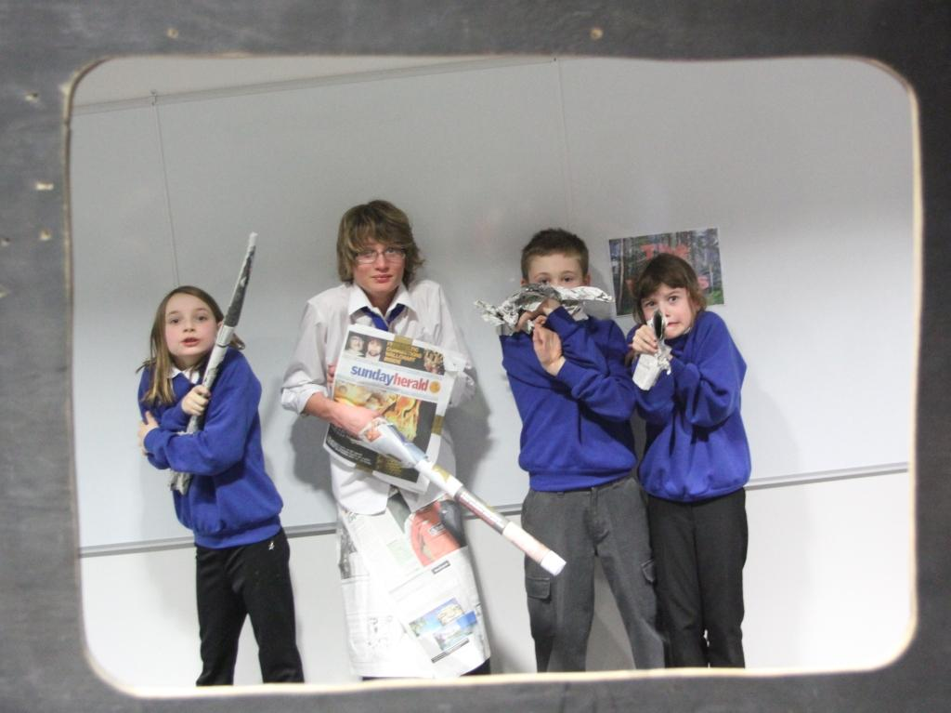 | Message/Meaning:  Main emotion:

