Descriptive Paragraph Brainstorming
Sight
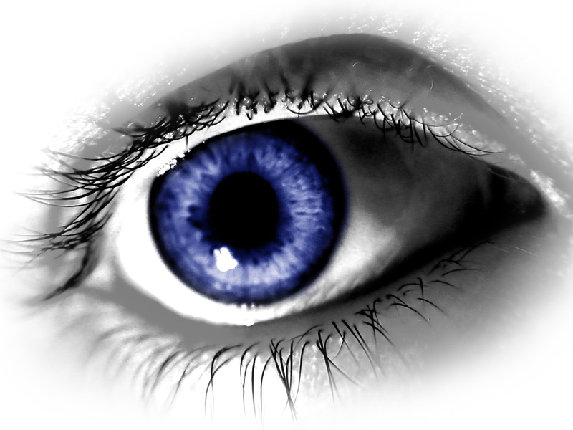

Touch


Topic
Taste

Sound

Smell

