CR ASSESS and REFLECT Listening Name_______________________
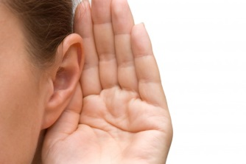I was a good listener today. Yes or No

Check off the reasons for listening.
_____ I want to learn something new.
_____ Listening will save me time.
_____ I will know what to do when I am working.
_____ It will make me a better team member.
_____Listening will help me solve problems.
_____I will feel good when I know what to do.

Tell one thing that would make you a better listener tomorrow.
__________________________________________

