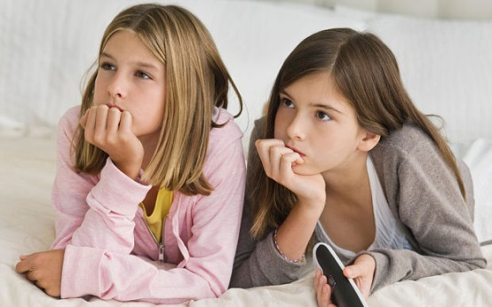
ASSESS and REFLECT CR Name _________________________________

Viewing:

This is the reason I was watching with my eyes (main idea):

These are three things I know by using my eyes only:
a)

b)

c)

I can connect what I am seeing to my own life because:

This reminds me of a different text that I have read:

I see how what I am viewing connects to the world:
 |  | Fully meeting expectations, with enriched understanding (EU) | Fully meeting grade level expectations (FM) | Mostly meeting grade level expectations (MM) | Not yet meeting grade level expectations (NY)
Ideas & Information | Identify the purpose / main idea | You are able to identify the purpose or main idea in the visual text with detail. | You are able to identify the purpose or main idea in the visual text. | You are able to identify the purpose or main idea with assistance. | Think: What is the purpose of this visual text? What are the before, during, after strategies that might help you identify the meaning? You need to spend time examining the strategies to understand the purpose / main idea.
Respond to and Analyze Texts | Explain reactions and connections | You are able to accurately and clearly explain your reactions and make connections (self, text – text, world) to the visual text with detail. | You are able to accurately and clearly explain your reactions and make connections (self, text – text, world) to the visual text. | You are able to accurately and clearly explain your reactions and make connections (self, text – text, world) to the visual text with assistance. | Think: How can you explain your reactions and make connections to this visual text? You need to revisit the visual text and rethink your response.

Why is it sometimes way more important to use your eyes than your mouth?

ASSESS and REFLECT CR Name _________________________________

Viewing: Today you were asked to only use your eyes to learn.

Was this hard for you?
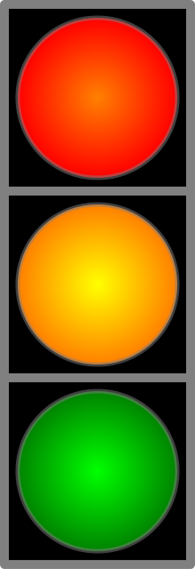
Easy so-so hard

Why?____________________________________________________________________________

Draw three things that you learned by using your eyes only


ASSESS and REFLECT CR Name _________________________________

READING

Authors give us lots of clues about what we are reading through text features. List the text features that helped you to get clues while you were reading today.

Text Feature 1:

Text Feature 2:

Text Feature 3:

Text Feature 4:

Text Feature 5:

What does this tell you about the importance of (eyes) viewing during reading?

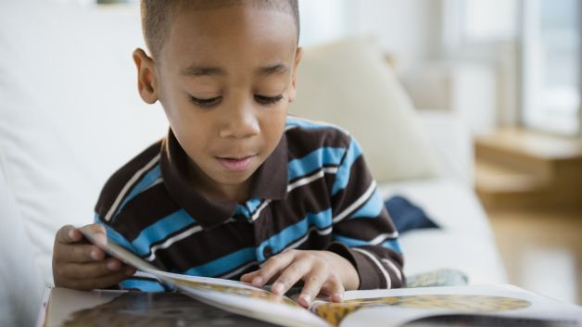
ASSESS and REFLECT CR Name _________________________________

How was reading for you today:

Easy so-so hard
What made it hard/easy for you?
_________________________________________________________________________________
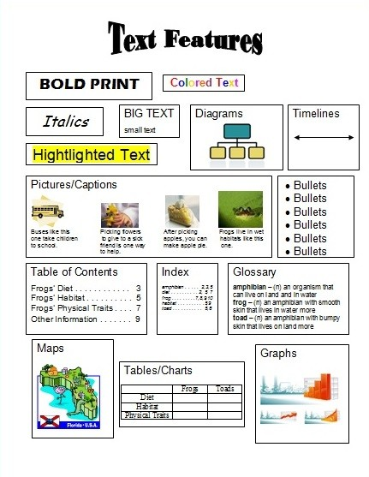

Highlight the text features that you used to help make your reading easier. Which two features do you wish you would have paid closer attention to and why?

ASSESS AND REFLECT CR Name_______________

What are the top three text features that I do not understand and would like to learn more about:

1._________________________________________

2._________________________________________

3._________________________________________

Which text feature do I use over and over again/?

Why is this text feature so reliable for me?
_________________________________________________________

Circle the text features above that you consistently use when using a device such as an i-phone, i-pad, i-pod etc.
Can you translate the technical skills that you have on your device to a book? Explain.

