MATH JOURNAL RUBRIC
Mathematical Processes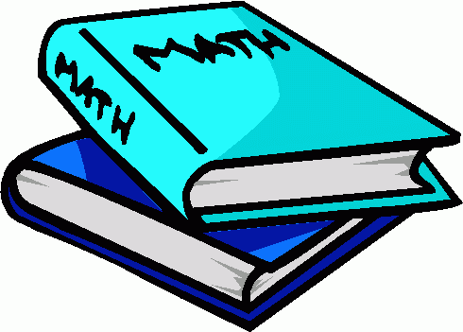 | Fully meeting expectations, with enriched understanding (EU) | Fully meeting grade level expectations (FM) | Mostly meeting grade level expectations (MM) | Not yet meeting grade level expectations (NY)
Communication | You confidently use pictorial, symbolic and written expressions to demonstrate your understanding of mathematical ideas. There is evidence that you have linked prior knowledge to new learning. | You often use pictorial, symbolic and written expressions to show your understanding of mathematical ideas. You need to reflect at a deeper level to show connections of prior knowledge to new learning. | With support, you are able to use pictorial, symbolic and written expressions to show understanding of mathematical ideas. How does this link to what you already know? How can you show what you know in your head? How do you explain your strategies? | You need practice using pictorial, symbolic and written expressions to show understanding of mathematical ideas. Are you addressing each part of the prompt? What are your strengths in showing what you know? Can you link this to something you already know?
Reasoning | Youconsistently show a logical sequence of thought. You areable to reason and explain your understandings at very high levels of thinking. You can independently adjust your work based on information gathered to reach new conclusions. | You often show a logical sequence of thought. You are able to reason and explain your thinking. Try forming new conclusions based on what you already know. | With support, you can sequence your thoughts and ideas and explain your thinking. What patterns do you see? Have you looked at all your observations? Are you responding to each part of the prompt in sequence? | You need to practice and watch others to learn to sequence your thoughts. You find it difficult to explain what you know by writing it down. Have you asked yourself questions about the prompt? Can you use a strategy to explain what you know?
Connections | You can naturally see how mathematical ideas are connected to each other and to the real world. You view math as useful, relevant and integrated. You see new problems as challenges that require new connections. | Seeing how ideas are connected to each other and to real life are making more sense to you. How can you challenge yourself to move beyond procedures to understanding? How is math useful to you outside of the classroom? | With one-to-one explanations, you can make connections between ideas and can see some real life applications. What does this remind you of that you have already learned?  How does this make sense in your own life? How would you explain this aloud? | You need practice and experiences to see how ideas are connected to each other or how math is part of life outside the school. Where and how do you use math in your life? What have you already learned that you can link this to? How is math connected to other areas that you are learning about?
Terminology | You confidently use correct math terminology when responding to math prompts.This enhances your message and shows your understanding of the concepts. | You often use correct math terminology when responding to math prompts. Remember to check that all parts of the prompt have been addressed so as to include all terminology. | You include some correct math terminology when responding to the prompt. Have you used the correct math terms for each part of the prompt? Are you substituting words that have the same meaning as these terms? What resources (checklists, charts, fishbowls) do you have available to support you in this area? | You need continued practice to use correct math terminology. What words can you substitute in place of the terms you are already using? What math terms could you copy right from the prompt? Can you refer back to prior prompts for clues? What is the prompt asking you?

