Book Leveling Supports (Acknowledging the Jennifer Serravallo book, Understanding Texts and Readers, 2018)
 | Level 12 | Level 13 | Level 14
Text Layout  -font  -placement  - number of words or sentences | − Print may vary from medium to small  − Paragraphs are set off with some paragraphs indented  − Captions in nonfiction range from single word to phrases  − Variety of text placement | − Some early chapter books  − Layout varies widely  − Captions with phrases and/or sentences  − Some use of graphic organizers in nonfiction text  − Length varies—16+ pages | − Table of contents, glossary, index may be introduced in some nonfiction texts  − Length of book may be increasing  − Most books 24 pages in length
Vocabulary & Sentence Structure | − More challenging high frequency words introduced  − Increasingly complex sentences structures for effect  − Exceptions to standard punctuation and spelling  − Beginning to use idioms, similes and metaphors | − Specialized vocabulary embedded into text  − Challenging high-frequency words occur naturally in text  − Prepositional phrases often at beginning of sentences  − Wider use of poetic language | − More detailed (technical/descriptive) form of dialogue  − Formal dialogue  − Varied syntax  − Multiple phrases in one sentence  − Literary language and text structure
Story Structure | − Single event continues over several pages  − Conversation over many characters  − Multiple characters  − More inference required  − Text with distinctive beginning, middle and end  − Multiple episodes  − Higher level concepts | − Well developed story structure  − Inference required to predict story line  − Comprehensive development of literary elements  − Many new and unfamiliar concepts  − Details found in text | − Content of text moves away from familiar experiences  − May be repeating episodes or events  − Characters in stories tend to learn and change  − Events require interpretation
Illustrations | − Mix of illustrations, photos, diagrams, graphs, etc  − Illustrations and photographs still mostly in color  − | − Illustrations provide low to moderate support; helps children understand and interpret the text  − Color and black and white illustrations used | − Pictures still appear on most pages of the texts  − Enhances meaning and arouses interest  − Inferring from photographs, pictures
Supporting Reading Strategies | − Reads with fluency and phrasing  − Demonstrates using beginning chunks/syllables and analogies to problem-solve unknown word  − Reader's understanding in influenced by prior knowledge | − Reads with fluency and phrasing  − Punctuation adds meaning  − Reflecting on story helps meaning  − Cross checking meaning and other cues to confirm vocabulary  − Inferences to interpret illustrations  − Text features (speech bubbles, illustrations are part of story, add information) | − Reads with fluency and phrasing  − Demonstrates using beginning chunks/syllables and analogies to problem-solve unknown word  − Textual—organization features in nonfiction add information
In fiction…look for students to: | - Retell multiple important events using texts and/or pictures.  - Understand cause and effect  - Identify multiple aspects of a scene’s main problem  - Name the setting  - Identify one or more less obvious traits and/or feelings of a main character  - Describe how a main character’s feelings have changed.  - Use scene-level context to explain the meaning of a word or phrase  - Articulate one of the book’s lessons/themes based on most of the story’s events.
In non-fiction…look for students to: | - Quote or paraphrase a sentence or heading that captures the main idea of a section of the text  - State a main idea of the whole book, taking most of it into consideration  - Support a main idea with several key details from the text’s words and pictures.  - Compare or contrast details from words and/or pictures.  - Provide a complete definition of the word or phrase drawing heavily on the text and pictures.  - Learn from information from a text features and explain how it connects to information in the main text.
Examples of Fiction Books |  |  | - The Clifford and the Big Red Dog series by Norman Bridwell  - Baseball Ballerina by Kathryn Cristaldi  - Have You Seen Duck? By Janet A. Holmes  - The Katie Woo series by Fran Manushkin  - The Fox series by Edward Marshall  - The Little Bear series by Else Homelund Minarik  - The Henry and Mudge series by Cynthia Rylant  - The Mr. Putter and Tabby series by Cynthia Rylant  - Fiesta Babies by Carmen Tafolla
Examples of Non-fiction Books |  |  | - Bears by Amy Levin  - Insects by Carolyn MacLulich  - Shadows by Carolyn B. Otto  - Ants by Rebecca Rissman  - Fantastic Frogs! By Fay Robinson  - About Habitats: Oceans by Cathryn Sill  - Fabulous Fishes by Susan Stockdale  - All Kinds of People: What Makes Us Different by Jennifer Waters  - Bats by Lily Wood  - Play Ball! By Vanessa York
(i.e) | 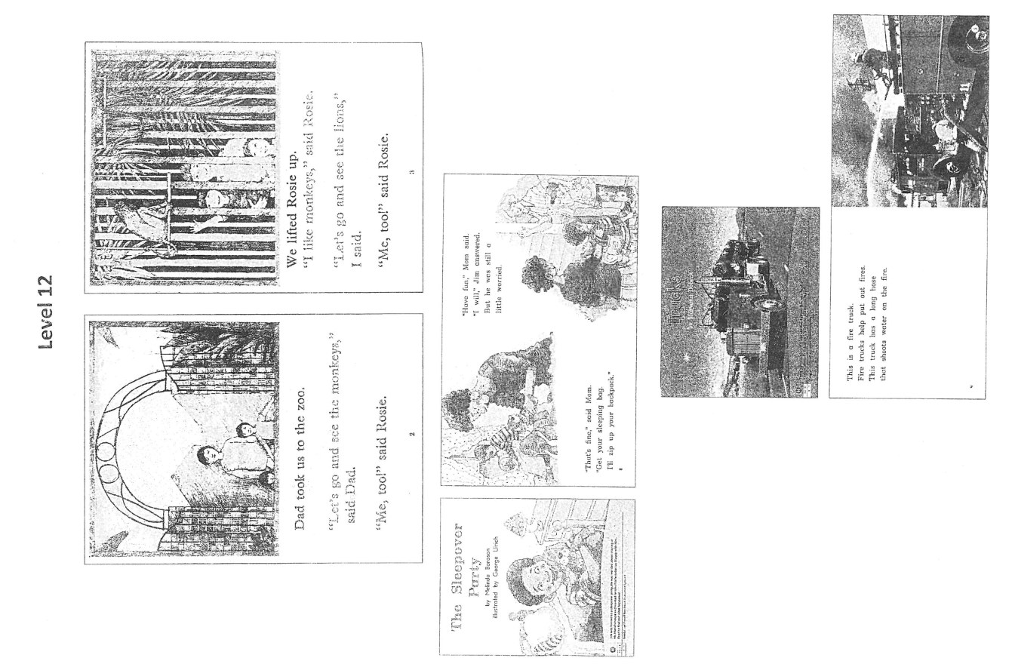 | 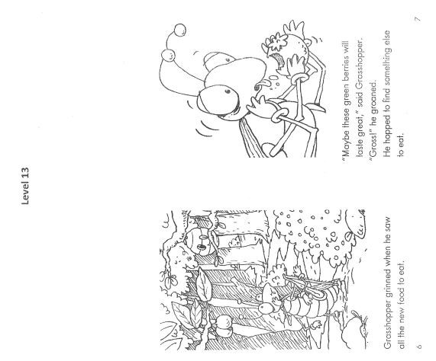 | 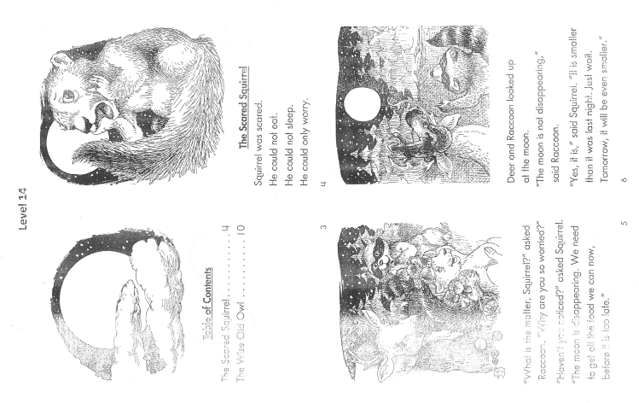

 | Level 15 | Level 16 | Level 17
Text Layout  -font  -placement  - number of words or sentences | − More difficult vocabulary, challenging content, or more complex themes  − Print size varies and often smaller  − Early chapter books  − 24—32 pages of text  − Early chapter books of approximately 32 pages | − Paragraphs usually indented  − Captions may be full page with illustrations/photos  − Chapter book and many longer stories and picture books | − Lots of text in small print with narrower word spacing  − Very long stories, includes many picture books  − Chapter book and many longer stories and picture books  − Chapter books up to 64 pages with short chapters
Vocabulary & Sentence Structure | − Variety of vocabulary continues to expand  − Information books may contain technical language and harder vocabulary words  − Longer, more complex sentences (added prepositional phrases) | − Variety of vocabulary continues to expand  − Multi-syllable and some technical words  − Informational books may contain technical language and harder vocabulary words  − Sentences are complex  − Multi-phrasal sentences  − Dialogue not always assigned | − Variety of vocabulary continues to expand  − Multi-syllable and some technical words  − Informational books may contain technical language and harder vocabulary words  − Vocabulary introduced to create feeling or mood  − Sentences are complex  − Complex language may require interpretation
Story Structure | − Multiple episodes related to a single plot but may cover a longer time period  − Text may contain a great deal of dialogue | − Full range of genres  − More sophisticated plots with characters that are developed throughout the text  − Stories take place over a longer period of time  − Some unusual formats | − Full range of genres  − Variety of formats with many different conventions used to organize text and convey meaning  − Texts may have subtle meaning that require interpretation and more background knowledge
Illustrations | − Used to create interest, enhance meaning, and convey information Illustrations at many places in text  − Beginning to see black and while illustrations  − Offer additional story support  − Inferencing required from photographs  − Photographs dominate nonfiction but also some graphs, and diagrams | − Used to create interest, enhance meaning and convey information  − Illustrations at many places in text  − Texts include illustrations but readers less dependent on them  − Offer additional story support  − Mix of photographs, illustrations, and graphic organizers | − Used to create interest, enhance meaning, and convey information  − Illustrations at many places in text  − Texts include illustrations but readers less dependent on them  − Chapter books longer with fewer pictures
In fiction…look for students to: | - Retell multiple important events using text and/or pictures  - Understand cause and effect  - Identify multiple aspects of scene’s main problem  - Name the setting  - Identify one or more less obvious traits and or feelings of a main character  - Describe how a main character’s feelings have changed and its significance (shift from Level 14)  - Use scene-level context to explain the meaning of a word or phrase  - Articulate one of the book’s lessons/themes based on most of the story’s events
In non-fiction…look for students to: | - Quote or paraphrase a sentence or heading that captures the main idea or section of the text  - State a main idea of the whole book, taking most of it into consideration  - Support a min idea with several key details from the texts words and pictures  - Compare or contrast details from words and/or pictures  - Provide a complete definition of the word or phrase, drawing heavily on the text and pictures  - Learn information from a text feature an explain how it connects to information in the main text | - Quote or paraphrase a sentence or heading that captures the main idea or section of the text  - State a main idea of the whole book, taking most of it into consideration  - Support a min idea with several key details from the texts words and pictures  - Identify multiple similarities and differences, and categorize comparisons, using key details from the text (shift from level 15)  - Provide a complete definition of the word or phrase, drawing heavily on the text and pictures  - Learn information from a text feature an explain how it connects to information in the main text | - Quote or paraphrase a sentence or heading that captures the main idea or section of the text  - State a main idea of the whole book, taking most of it into consideration  - Support a min idea with several key details from the texts words and pictures  - Identify multiple similarities and differences, and categorize comparisons, using key details from the text  - Provide a complete definition of the word or phrase, drawing heavily on the text and pictures  - Learn information from a text feature an explain how it connects to information in the main text
NESD Fiction Rubric |  | - Recognize and explain author’s ideas  - Identify characters and character traits  - Read fluently (93-100% accuracy)  - Identify setting  - Identify sequence of events  - Recognize and explain implicit and explicit messages  - Identify problem and solution
NESD Non-fiction Rubric |  | - Recognize and explain author’s ideas  - Read fluently (93-100% accuracy)  - Recognize the following text structures and features: diagram; heading; table of contents; glossary.  - Retell key ideas and specific details  - Recognize and explain implicit and explicit messages.
Plot & Setting  *Retelling Important Events  *Synthesizing Cause & Effect *Identifying Problems  * Visualizing Setting | A second grader, read Frog and Toad and was able to explain the cause-and effect relationship between two events.  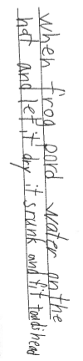  This student is able to accurately identify a main problem in Frog and Toad. This is the main problem because most of the plot revolves around trying to solve or resolve this problem. The use of the word and means that they are not looking at the problem simplistically; they can see multiple ways the problem is impacting the characters. The problem articulated also aligns to the title of the short story, “Alone”  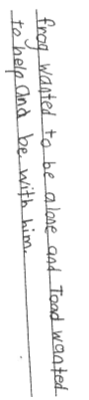 | Notice how this second grader is able to retell multiple important events in sequence from an early-in-the-book scene in Cam Jansen and the Stolen Diamonds.  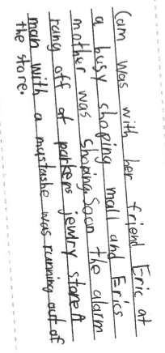
Character  *Inferring about, Interpreting, and Analyzing Main Character(s)*Synthesizing Character Change  *Inferring About, Interpreting, and Analyzing Secondary Characters | This second-grade reader uses a precise character trait to describe Toad in the short story from Days with Frog and Toad. The reader also elaborates on their idea with a detail from the text.  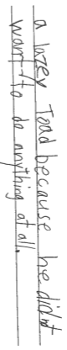 | When reading Cam Jansen and the Mystery of the Stolen Diamonds, this second-grade reader stopped to jot about the kind of person Cam, the main character is. Notice that they use multiple traits to describe her: (adventurous [avanchis], sneaky, brave). Naming multiple traits is something we normally wouldn’t expect of a reader until level 20 when characters get more complex. From a reader of a text at level 16, this reader is very attuned to character traits.  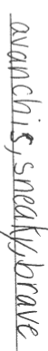
Vocabulary and Figurative Language*Monitoring for Meaning and Using Context | This first-grade reader read Frog and Toad Are Friends. When Toad says he feels “down in the dumps” as he looks around at his messy house that needs cleaning the student explains their feeling of sadness with details from the text, which shows that they understand the meaning of the phrase within the context of the story.  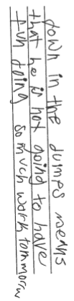 | This second-grader explains the meaning of the phrase “caused a great commotion” from Cam Jansen and the Mystery of the Stolen Diamonds. Notice how the reader defines it (“made a big mess”) and then elaborates with details from the context of the story. This shows that the reader is able to derive meaning from the scene to figure out the meaning of this phrase.  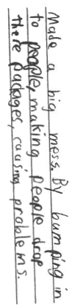
Themes and Ideas  *Interpreting a Story by Naming Life Lesson(s) or Theme(s)*Identifying and Interpreting Social Issues  *Identifying and Interpreting Symbols | This first grader read Days with Frog and Toad and was able to come up with a lesson that relates to the main events of the plot.  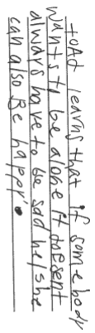
Examples of Fiction Books | - The Franklin series by Paulette Bourgeois  - Jamaica’s Find by Juanita Havill  - Andy Shane and the Very Bossy Dolores Starbuckle by Jennifer Jacobson  - The Sofia Martinez series by Jacqueline Jules  - The Story of Ferdinand by Munro Leaf  - The Ling & Ting series by Grace Lin  - Days with Frog and Toad by Arnold Lobel  - The Day Jimmy Boa Ate the Wash by Trinka Hakes Nobel  - The Black Lagoon Adventures by Mike Thaler | - The King and Kayla series by Dori Hillestad Butler  - The Pinky and Rex series by James Howe  - The Horrible Harry series by Suzy Kline  - The Milo and Jazz Mysteries series by Lewis B. Montgomery  - The Amelia Bedelia series by Peggy Parish  - The Ricky Ricotta’s Mighty Robot series by Dave Pilkey  - Robert and the Triple Rotten Day by Barbara Seuling  - The Oliver and Amanda series by Jean Van Leeuwen  - A Brandy-New Day with Mouse and Mole by Wong Herbert Yee | - The Cam Jansen series by David A. Adler  - The Nate the Great series by Marjorie Weinman Sharmat  - Arthur chapter books by Marc Brown  - Jigsaw Jones Mystery series by James Preller  - Junie B. Jones series by Barbara Park  - Through the Garden Door by Barbara Reeves  - Wisahkecahk Flies to the Moon by Freda Ahenakew  - Cloudy with a Chance of Meatballs by Judi Barrett
Examples of Non-fiction Books | - Bees by Susan Ashley  - Skip through the Season by Stella Blackstone  - Earth Day by Clara Cella  - 15 Facts About Snakes by Julie Haydon  - Eagles: Endangered! by Karen Haywood  - Big Cats by Joyce Milton  - Bull Sharks by Deborah Nuzzolo  - Different Homes Around the World by Pamela Rushby  - Ants and Aphids Work Together by Martha E.H. Rustad  - 10 Things I Can Do to Help My World by Melanie Walsh | - Frogs by Eliabeth Carney  - The Power of the Wind by Mary Beth Crum  - Horse Show by Kate hayden  - What Do You Do with a Tail Like This? By Steve Jenkins and Robin Page  - Rescuing Stranded Whales by Marianne Lenihan  - Amazing Animals by Kate Riggs  - Pumpkins by Ken Robbins  - Firefighters to the Rescue Around the World by Linda Staniford  - Energy in Motion by Melissa Stewart | - The Cloud Book by Tomie dePaola  - Fort Chipewyan Homecoming by Mecredi Morningstar  - How to do Homework Without Throwing Up by Trevor Romain  - What Am I Made Of? By David Bennett
(i.e) | 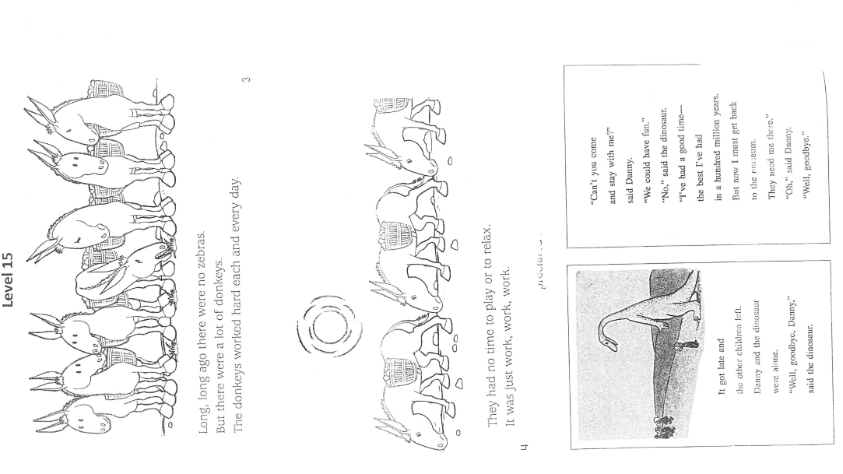 | 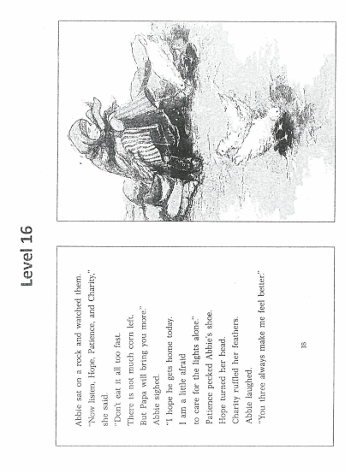 | 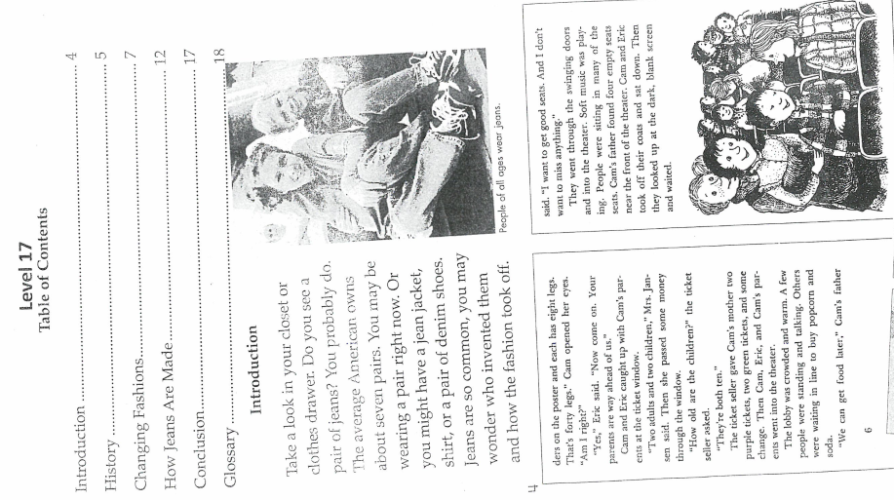

 | Level 18 | Level 19 | Level 20
Text Layout  -font  -placement  - number of words or sentences | − Lots of text in small print with narrower word spacing  − Very long stories, includes many picture books  − Chapter book and many longer stories and picture books (approximately 100 pages) | − Increased difficulty of text  − Small print with narrow word spacing  − Longer chapter books between 100 pages  − Chapter length increasing  − Chapter books approximately 100 to 200 pages | − Length not as important as difficulty of text  − Very long stories and picture books  − Usually a table of contents, index and may have a glossary  − Most books are long
Vocabulary & Sentence Structure | − Variety of vocabulary continues to expand  − Multi-syllable and some technical words  − Vocabulary support many be required  − Content specific vocabulary may be unfamiliar  − Words are used for a range of connotative meaning  − Sentences are complex  − Complex language may require interpretation  − May require a cultural or historical context for interpretation | − Vocabulary is sophisticated and varied  − Many more multi-syllable words are included  − Highly complex sentences require a full range of punctuation which is important to the meaning of the text  − Interpretation of meaning will be required  − Many compound words | − Vocabulary is sophisticated and varied  − Many more multi-syllable words  − May have unfamiliar content– specific words  − Highly complex sentences may require a full range of punctuation which is important to the meaning of text  − Sophisticated language and plays on words  − May require cultural or historical context for interpretation
Story Structure | − Full range of genres  − Irony and whimsy is used to created interest and convey the nature of characters | − A lot of personification (metaphors, similes, etc.)  − Subtle meanings  − May require cultural or historical context for interpretation | − Full range of genres  − Literary and informational text where information is from a variety of structures/features  − Texts must be comprehended on a literal and figurative level to really understand them.
Illustrations | − Complex picture books used for particular purposes rather than become the norm  − More black and while line illustrations  − More technical information include in illustrations and graphic organizers | − May include black and white line illustrations  − May include technical information included in illustrations and graphic organizers in non-fiction texts  − More black and white line drawings in fiction | − Complex picture books used for particular purposes rather than be the norm  − More black and white line drawings in fiction  − More technical information included in illustrations, graphics in non fiction texts.
In fiction…look for students to: | - Retell multiple important events using text and/or pictures.  - Understand cause and effect  - Identify multiple aspects of a scene’s main problem  - Name the setting  - Identify one or more less obvious traits and/or feelings of a main character  - Describe how a main character feelings have changed and its significance  - Use scene-level context to explain the meaning of a word or phrase  - Articulate one of the book’s lessons/themes based on most of the story’s events. | - Retell multiple important events using text and/or pictures.  - Understand cause and effect  - Identify multiple aspects of a scene’s main problem  - Name the setting  - Identify several less obvious traits and/or feelings that reveal different aspects of a main character (shift from level 18)  - Describe significant changes in a main character (shift from level 18)  - Identify many feelings and/or traits of secondary characters (shift from level 18)  - Use scene-level context to explain the meaning of a word or phrase  - Articulate one of the book’s lessons/themes based on most of the story’s events.
In non-fiction…look for students to: | - Synthesize most details from pictures and words in a section of the text to state a main idea, using original language (shift from level 17)  - Take the whole book into account to state a main idea (shift from level 17)  - Support a min idea with several key details from the texts words and pictures  - Identify multiple similarities and differences, and categorize comparisons, using key details from the text  - Explain or describe meaning of a word or phrase using larger context, including text features (shift from level 17)  - Learn information from a text feature an explain how it connects to information in the main text
Plot & Setting  *Retelling Important Events  *Synthesizing Cause & Effect  *Identifying Problems  * Visualizing Setting | This student, reading Jake Drake, Bully Buster draws connections between multiple causes to explain a character’s action in one part of the story. There wasn’t only one reason why Jake says that Link made “it” (a project) – there is more than one, and this reader names both. This shows he’s able to synthesize more of the text to truly understand the “why” of the present scene.  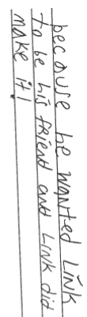  This student read Stuart Goes to School. Notice how she describes multiple aspects of the problem – not only did Stuart’s actions cause him to disappear from the classroom, but he wound up on the roof of the school and couldn’t get down. All three of these relate to one main problem.  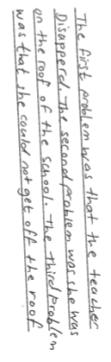  This student accurately names the time and place in this the book Stuart Goes to School.  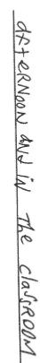 | This student is reading Fourth Grade Rats and stops to jot about a part when Suds is mad a Joey. She names multiple reason – Joey was not trying hard enough. Joey isn’t really a rat. The student is demonstrating an understanding of how there can be more than one cause for each event in a story.  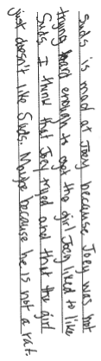 | This response to a moment in Loser shows how a fifth grader is considering multiple causes and effects. They are applying what they now about Zinkoff (that others have called him a loser, but here’s he’s not one), how he’s afraid of the dark (*learned earlier in the story), and that others are searching for this lost girl in addition to Zinkoff.  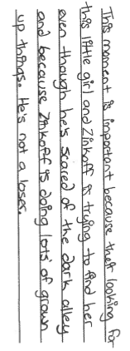
Character  *Inferring about, Interpreting, and Analyzing Main Character(s)  *Synthesizing Character Change  *Inferring About, Interpreting, and Analyzing Secondary Characters | This second-grade reader thinks about the main character, Judy (Juty), in this short jot about Judy Moody Saves the World. Notice that the student is considering a change in feelings. Books at this level usually have characters who don’t change in major ways, except they do experience changes in feelings. Her writing shows she’s tracking these changes in the main characters.  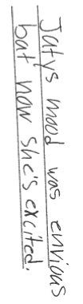 |  | This third-grader is thinking about Amber, the title character in Amber Brown is Not a Crayon. Notice how the reader does not simply name one trait about Amber but instead lists several things that show different sides to the character. This shows that the reader is accumulating text details.  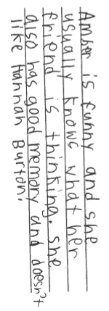  This student is also thinking about a secondary character. Notice how the reader names multiple feelings (worried) and traits (kind, understanding) of the character. The reader is also not thinking about the character in isolation, but rather about how they can relate to the main character (Amber/her daughter).  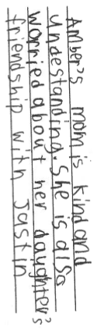
Examples of Fiction Books | - The Ivy Bean series by Annie Barrows  - Freckle Juice by Judy Blume  - The Paint Brush Kid by Clyde Robert Bulla  - The Bink and Gollie series by Kate DiCamillo  - The Riverside Kids series by Johanna Hurwitz  - The Captain Awesome series by Stan Kirby  - The Judy Moody series by Megan McDonald  - The Magic Tree House series by Mary Pope Osborn  - The Stuart Series by Sara Pennypacker  - The Marvin Redpost series by Louis Sachar | - Stanley in Space by Jeff Brown  - Neekna and Chemai by Jeanette Armstrong  - Mikey Mite Goes to School by Gilles Gauthier  - Kallie Fetches the Dragon by Sally Odgers  - Horrible Harry Bugs the Three Bears by Suzy Kline  - The Goalie Mask by Mike Leonetti  - Fred and the Stinky Cheese by Marie Danielle Croteau | - My Name is Maria Isabel by Alma Flor Ada  - A matter of Fact Magic series by Ruth Chew  - The Magic Finger by Roald Dahl  - Amber Brown Is Not a Crayon by Paula Danziger  - Donavan’s Word Jar by Monalisa DeGross  - How to Be Cool in the Third Grade by Betsy Duffey  - Make Way for Dyamonde Daniel by Nikki Grimes  - Be A Perfect Person in Just Three Days! by Stephen Manes  - The A to Z Mysteries series by Ron Roy
Examples of Non-fiction Books | - Howl! A Book About Wolves by Melvin and Gild Berger  - My Fist Book About the Internet by Sharon Cromwell  - From Seed to Plant by Gail Gibbons  - Who Eats What? Food Chains and Food Webs by Patricia Lauber  - Manatees by Patricia A. Fink Martin  - Diwali: Hindu Festival of Lights by June Preszler  - Caring by Lucia Raatma  - Busy Bees by Margaretha Takmar  - Hurricanes and Tornadoes by Kate Waters | - My Elephant, My Friend by Vanessa York  - Kids in Action by Leslie Garrett  - How Leaves Change Color by Christine Figorito  - Endangered and Extinct by Judith Stamper  - Giving Thanks by Barbara Greenwood | - Gung Hay Fat Choy by June Behrens  - One Tiny Turtle by Nicola Davies  - The Cloud Book by Tomie dePaola  - Save the Manatee by Alison Freisinger  - Ants, Bees, and other Social Insects by Kris Hirschmann  - Tornadoes! By Lorraine Jean Hopping  - Pompeii…Buried Alive! By Edith Kunhardt  - The Real Poop on Pigeons by Kevin McClosky  - Sod Houses on the Great Plains by Glen Rounds  - Endangered Animals by Lynn M. Stone
(i.e) | 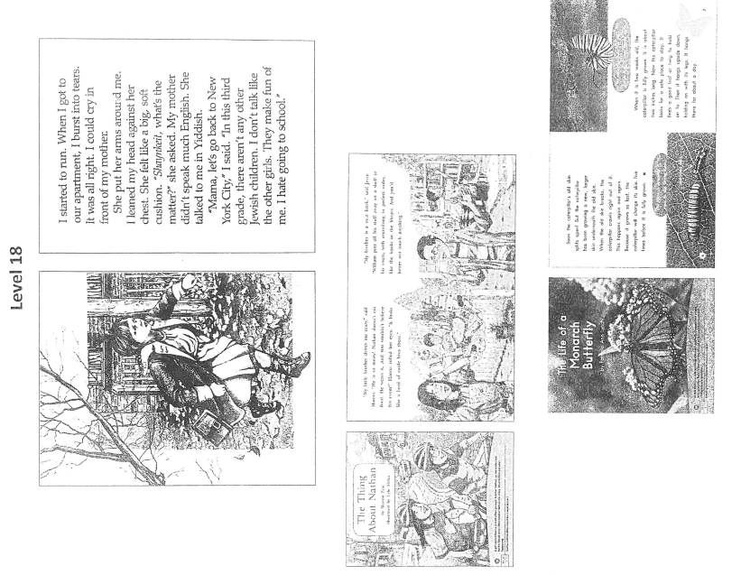 | 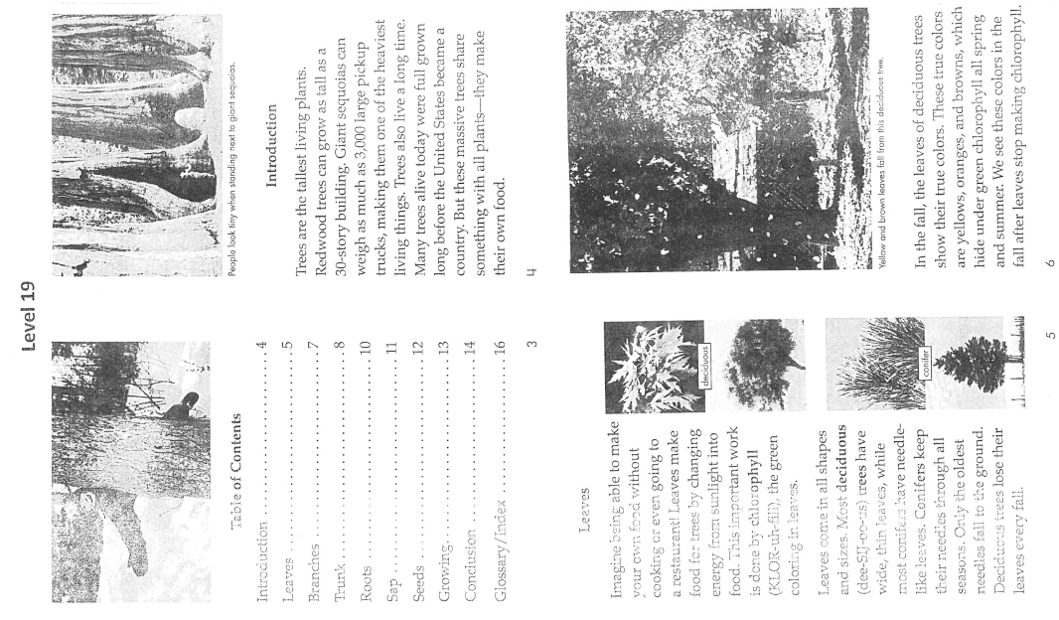 | 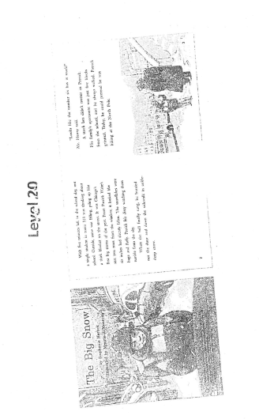  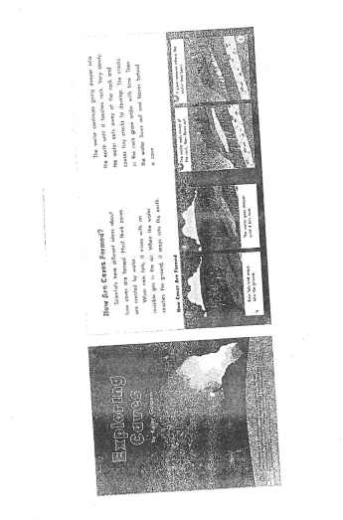

 | Level 21 | Level 22 |  | Level 23
Content/  Themes/Ideas | − Critical thinking required to judge authenticity of texts  − Content supported/extended by illustrations in most information texts  − Multiple themes s may be understood in many layers | − Critical thinking required to judge authenticity of texts  − content load in many texts, fiction and nonfiction requiring study  − Some texts with settings distant in time space from students’ experiences  − Multiple characters revealed by what they think, say, do and what others say/think about them |  | − Critical thinking required to judge authenticity of texts  − Heavier content load in many texts, fiction and nonfiction requiring study  − Content requiring reader to begin to take on diverse perspectives (race, language, culture)  − Multiple themes may be understood in many layers
Text Structure | − Fiction - complex plots, beginning to have multiple story lines  − Usual text organizations such as flashbacks  − Plots with detailed episodes  − Non-fiction - underlying structure—description, compare/contrast, temporal sequence, problem solution, cause/effect  − Variety in organization and topic  − Some texts with several topics organized categorically  − Shorter texts (approximately 24—48 pages of print) on single topics (usually non-fiction)  − Large variation of print styles and font size (related to genre)  − Many texts with small font  − Use of bold, larger font, or italics for emphasis or to indicate importance or level of information | − Fiction - complex plots, many with multiple story lines  − Usual text organizations such as flashbacks  − Plots with detailed episodes  − Plots with subplots  − Some short stories with plots intertwining  − Non-fiction - underlying structure—description, compare/contrast, temporal sequence, problem solution, cause/effect  − Variety in organization and topic  − Many texts with small font  − Use of bold, larger font, or italics for emphasis or to indicate importance or level of information  − Variety in layout of nonfiction formats (question/answer, paragraph boxes, legends..) |  | − Fiction - complex plots, many with multiple story lines  − Unusual text organizations such as flashbacks  − Some short stories with plots intertwining  − Non-fiction - underlying structure—description, compare/contrast, temporal sequence, problem solution, cause/effect  − Variety in organization and topic  − Some texts with several topics organized categorically  − Chapter books 100 –300 pages  − Large variation of print styles and font size (related to genre)  − Use of bold, larger font, or italics for emphasis or to indicate importance or level of information
Vocabulary Words Sentence Structure | − Full range of genres  − Longer sentences , with dialogue and embedded phrases  − Sentences with nouns, verbs, or adjectives in series, divided by commas  − Increased variety/range of textual features/structures give information  − Texts must be comprehended on a literal and figurative level to really understand them | − Many sentences continuing over several lines or to next page  − Some texts in columns  − Some parenthetical material  − Range of declarative, imperative, and interrogative sentences |  | − Many new vocabulary words that readers must derive from context or use glossaries or dictionaries  − Many technical words  − Many longer descriptive words  − Words used figuratively or with unusual connotations  − Words with multiple meanings within the text  − Words used in regional or historical dialects  − May be some archaic words
Placement and Amount of Text |  |  |  | − Shorter texts (approximately 24—48 pages of print) on single topics (usually non-fiction)  − Chapter books 100 –300 pages  − 5—40 lines of print per page/more for fiction  − Large variation among print styles and font size  − Many texts with small font  − Use of bold, larger font, or italics for emphasis or to indicate importance or level of information  − Some text have dense print, difficult layout  − Variety in layout of nonfiction formats
In fiction…look for students to: | - Retell multiple important events (shift from Level 20)  - Draw connections between multiple causes and effects, and demonstrate deep understanding of the scene (shift from Level 20)  - Identify multiple aspects of the story’s main problem (shift from Level 20)  - Describe in some original detail the time(s) and place(s) (shift from Level 20)  - Identify several less obvious traits and/or feelings that reveal different aspects of a main character  - Describe significant changes in a main character by synthesizing many details  - Identify many feelings and/or traits of secondary characters  - Use scene-level context to explain the meaning of a word or phrase  - Articulate one of the book’s lessons/themes based on most of the story’s events  - Identify a social issue in the book and explain the complexity of that issue (shift from Level 20)
In non-fiction…look for students to: | - Synthesize most details from pictures and words in a section of the text to state a main idea, using original language  - Take the whole book into account to state a main idea and capture the complexity the author brings to the topic (shift from 20)  - Support a main idea with several key details from different pages or sections, using words, pictures, and text features (shifts from 20)  - Identify multiple similarities and differences, and categorize comparison, using key details from the text.  - Explain or describe the meaning of a word or phrase using larger context, including text features.  - Learn information from a text feature and explain how it connects to information in the main text.
NESD Fiction Rubric | - Recognize author’s ideas and intents – what did the author want to say? What are the relevant details?  - Identify characters and their traits.  - Identify setting with supporting details.  - Read fluently (93-100% accuracy)  - Identify the author’s content (topic/theme) and craft  - Understand the basic plot of the story  - Identify the problem and solution  - Express your opinion and connection to the text.
NESD Non-fiction Rubric | - Recognize author’s ideas and intent.  - Identify the main ideas and supporting details.  - Read fluently (93-100% accuracy)  - Identify various text structures and features  - Extract significant information (follow instructions or understand message of the text)  - Express your opinion and connections to the text.
Plot & Setting  *Retelling Important Events  *Synthesizing Cause & Effect  *Identifying Problems  * Visualizing Setting | This third grader’s retelling of an important scene in Chocolate Fever shows that he is able to retell multiple important events from the story. The retelling is clear and sequential, and one event clearly leads to the next. Retelling is more difficult in level 21 than level 16 because picture support drops considerably, so more of the events recalled come from text alone.  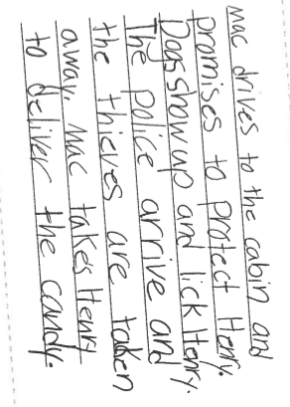  This fourth grader reader accurately describes the time (mediaeval times) and place (a dark path) and adds in some original details showing that the reader is visualizing in The Time Warp Trio: Knights of the Kitchen Table.  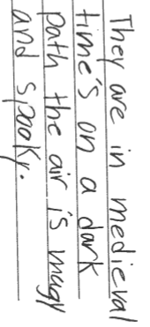 |  | Spelling aside, this second grader is thinking about Phil’s (“Fill”) problems in the story The Jacket. Notice how they name multiple problems (worried [woryed] that he’s prejudiced as well as acknowledging that Daniel [Danyal] doesn’t have a jacket because of him). The reader understood these problems from their reading of the text alone, because picture support at this level is minimal.  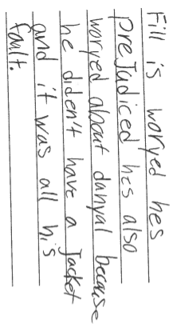  At this level, the student does more than simply name the setting at the beginning of Sadako and the Thousand Paper Cranes. She includes a more detailed description of the time, place and scene.  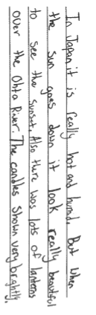 | As plot gets more complex, it becomes harder for the reader to understand why an event happens. In these cases, a reader may have to deal with flashbacks or foreshadowing or multiple events leading up to a moment. This fifth grade reader of The Great Gilly Hopkins shows they understand how events fit together.  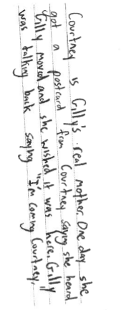
Character  *Inferring about, Interpreting, and Analyzing Main Character(s)  *Synthesizing Character Change  *Inferring About, Interpreting, and Analyzing Secondary Characters | This fourth-grader writes about the secondary character Mac in Chocolate Fever. Mac is a Mack truck driver who takes the main character, Henry, under his wing after Henry runs away out of embarrassment because of the brown spots on his skin from eating too much chocolate. Notice how Jessica names traits of the secondary character (“funny” and “nice”) and also the impact he has on Henry (“he was saying nice things to Henry”).  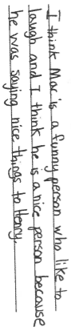 |  | A fifth grader writes about the main character in Sadako and the Thousand Paper Cranes. Notice how the reader names many traits about Sadako that reveal different sides. “Caring and thoughtful” are both positive traits that the student inferred from different parts of the book so far. “Impatient” can be viewed as weakness, showing another side to this complex character.  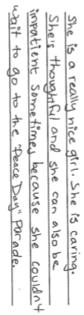  This third-grader recognizes the main changes that Koya’s showing at a critical scene in Koya DeLaney and the Good Girl Blues. The writing shows that the reader is thinking about multiple aspects of Koya (she wants to be good, but here she can’t, so she has to let out her anger) and even recounts an earlier dream scene that was important to understanding the character’s feelings.  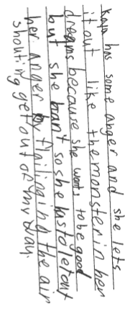 | This student interprets the main characters from Joey Pigza Swallowed the Key. Notice how the response combines multiple ideas about the character and what the character wants and draws a conclusion or develops an interpretation about him. This idea about Joey shows that the reader has synthesized a lot of information about him.  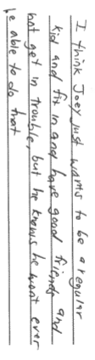  This fifth grader about the secondary character from Joey Pigza Swalled the Key. Notice how the reader infers and comments on traits as he describes character (she’s a “good person.” “She has been through a lot”) and describes her relationship to Joey and how Joey is impacted by her (“She loves him.” “He really feels loved and he wants to do better.”).  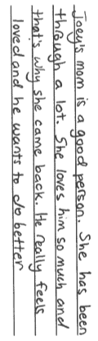
Vocabulary and Figurative Language  *Monitoring for Meaning and Using Context |  |  |  | A fifth-grader writes about figurative language in Joey Pigza Swallowed the Key. Notice how the reader’s explanation of the phrase. “I felt like Christmas was just a few days away, “makes sense with what’s happening in the scene, which involved conversations with Joey’s doctor and family about a medication that will help him with ADHD that he’s been struggling with for the entire story up to this point. The reader brings knowledge of the whole story to explain the meaning of the phrase.  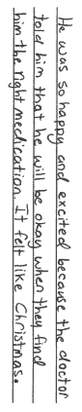
Themes and Ideas  *Interpreting a Story by Naming Life Lesson(s) or Theme(s)  *Identifying and Interpreting Social Issues  *Identifying and Interpreting Symbols | This third-grade reader writes about what they have learned after reading Jake Drake, Bully Buster. Notice how the reader is starting to see that stories can have more than one lesson or message, something typically expected at level 23 and above.  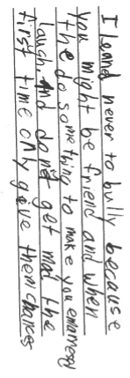This third-grader is thinking about the social issue of bullying. The reader identifies the issue (bullying) and draws conclusions/a lesson about what the author might be teaching about the issue. The interpretation aligns with the story.  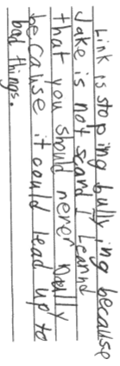 |  | This fifth grader infers a lesson that relates to the whole of Sadako’s story in Sadako and the Thousand Paper Cranes. Notice that the lesson inferred is not a cliché and that the reader identifies complexity in the lesson. The reader holds up two ideas simultaneously: that you should push yourself and not give up, but that even when you do, you may still not accomplish what you are trying for. This shows that the reader is considering different aspects of the plot.  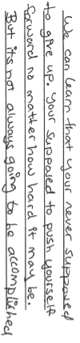  A fourth grader writes about the issues of gender in Fourth Grade Rats. In this quick jot, the reader shows how they are able to identify stereotypes that are presented in the book – boys have to be “all tough”, and girls have to like boys and are “all mushy”. The student doesn’t call this out as a stereotype, but that’s okay. An acknowledgement of stereotypes is something we typically see from readers’ responses beginning with their responses to level 23 books.  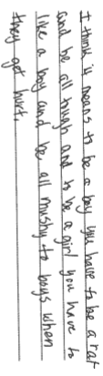 | This fifth –grader considers many of the author’s choices to be symbolic. The reader writes about multiple characters and how each character can represent a big idea or help add further insight into the main character. Considering characters and/or setting to be symbolic is often more challenging than considering objects to be symbolic.  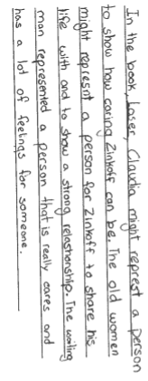
Examples of Fiction Books | - The Stories Julian Tells by Ann Cameron  - The Ramona series by Beverly Cleary  - Jake Drake, Bully Buster by Andrew Clements  - Baseball Fever by Johanna Hurwitz  - The Little Pear series by Eleanor Frances Lattimore  - Pippi Longstocking by Astrid Lindgren  - The Baby-Sitter Club by Ann M. Martin  - The Spray-Paint Mystery by Angela Shelf Medearis  - The Clementine series by Sara Pennypacker  - Chocolate Fever by Robert Kimmel Smith | - Stone Fox by John Reynolds Gardiner  - Koya DeLaney and the Good Girl Blues by Eloise Greenfiedl  - Almost Zero by Nikki Grimes  - Book Uncle and Me by Uma Krishnaswami  - The Alvin Ho series by Lenore Look  - Felita by Nicholas Mohr  - The Captain Underpants series by Dav Pilkey  - Gooseberry Park by Cynthia Rylant  - The Time Warp Trio: Knights of the Kitchen Table by Jon Scieszka  - The David Mortimore Baster series by Karen Tayleru
Examples of Non-fiction Books | - Germs Make Me Sick by Melvin Berger  - Beacons of Light: Lighthouses by Gail Gibbons  - Look What Came from Mexico by Miles Harvey  - Owls by Kevin J. Holmes  - Boy, Were We Wrong About Dinosaurs! By Kathleen V. Kudlinksi  - Wiggling Words at Work by Wendy Pfeffer  - Tropical Rain Forests by Darlene R. Stille  - Where Do Polar Bears Live? By Sarah L. Thomson  - At 1600 Pennsylvania Avenue by Crystal Wirth  - You Can’t Taste a Pickle with Your Ear: A Book About Your 5 Senses by Harriet Ziefert | - Safari by Robert Bateman  - The Let’s Look at Countries series by Nikki Bruno Clapper  - Arctic Babies by Kathy Darling  - The Moon Book by Gail Gibbons  - The Chicago Fire by Howard Gutner  - Africa by Christine Juarez  - The Our Physical World series by Ellen S. Niz  - Inclined Planes by Andrea Rivera  - Playypus by Joan Short, Jack Green, and Bettina Bird  - 31 Ways to Change the World by We are What we Do |  | - The 10 Coolest Moves to Stay Fit by Elizabeth Siegel
(i.e) | 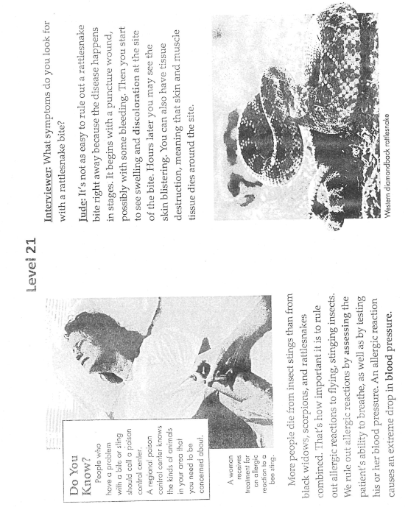 | 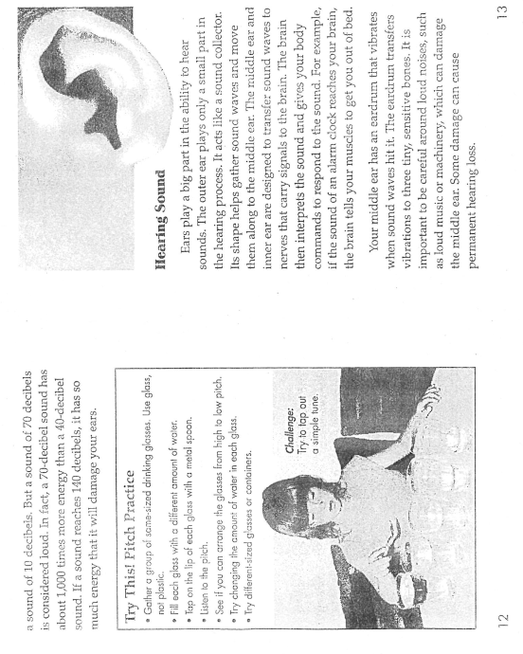 |  | 